SIMATS ENGINEERING
ASSESSMENT TOOL 1

COURSE NAME: COMPUTER NETWORKS COURSE CODE: CSA07

COURSE OUTCOME COVERED

CO5:
Measure network performance using key metrics with simulation tools
(BL4,BL5)

Assessment Tool Weightage: 40%

QUESTIONS: 3 Total Marks:30

Annexure A

Constraint-Based Problem Solving
- A multinational company is opening a new branch office in a remote rural location where high-speed wired internet is unavailable. The office must support cloud-based applications, video conferencing, and secure communication with the headquarters. The company has a limited budget for connectivity but requires uninterrupted business operations. As a network engineer, recommend a suitable internet connection, networking devices, and security mechanisms. Justify your recommendations by considering bandwidth limitations, reliability, cost, and future scalability
- A university plans to provide campus-wide wireless internet access for more than 3,000 students across classrooms, laboratories, libraries, and hostels. The network must support a large number of simultaneous users while minimizing signal interference and ensuring secure access. Due to budget constraints, only a limited number of wireless access points can be deployed. Analyze the requirements and propose an efficient wireless network design, including access point placement, frequency band selection, and authentication methods. Explain how your solution balances coverage, performance, security, and cost.
- A financial institution is upgrading its internal computer network to improve cybersecurity while allowing employees to access sensitive customer information and online banking services. The organization must comply with strict security policies without significantly affecting network performance or increasing operational costs. Design a secure network architecture by selecting appropriate network segmentation techniques, firewall deployment, authentication methods, and intrusion detection mechanisms. Justify your design by considering the constraints of security, performance, compliance, and budget.

RUBRICS FOR CALCULATION

Criteria | Weightage (%) | Exemplary (4) | Proficient (3) | Developing (2) | Beginning (1)
Understanding of Problem & Constraints | 20% | Clearly identifies all constraints and fully understands the problem requirements | Identifies most constraints with minor gaps in understanding | Identifies some constraints but misses key aspects | Shows little or no  understanding of constraints or problem
Problem  Decomposition | 15% | Breaks problem into logical, wellstructured subproblems effectively | Breaks problem into sub-parts with some logical flow | Attempts decomposition but lacks clarity or structure | No clear  decomposition  of the problem
Application of Constraints in  Solution | 20% | Applies all constraints correctly and consistently in solution design | Applies most constraints correctly with minor errors | Applies some constraints but with noticeable errors | Fails to apply constraints appropriately
Logical  Reasoning &  Strategy | 15% | Uses strong, clear, and efficient reasoning strategies | Uses generally sound reasoning with minor gaps | Reasoning is partially correct but inconsistent | Reasoning is unclear or incorrect
Solution  Accuracy &  Feasibility | 15% | Solution is fully correct, feasible, and optimized | Solution is mostly correct and feasible | Solution has errors or is partially feasible | Solution is incorrect or not feasible
Creativity & Innovation | 5% | Demonstrates highly innovative and unique approach | Shows some  creativity in approach | Limited creativity shown | No creativity; relies on basic or copied ideas
Clarity of  Presentation | 10% | Solution is clearly presented with excellent organization and explanation | Presentation is clear with minor issues | Presentation lacks clarity or organization | Poorly presented and  difficult to understand

ANSWERS

- Remote Rural Branch Office – Internet & Secure Connectivity

Problem Analysis
The company is opening a branch in a remote rural area where high-speed wired Internet is unavailable.
Main constraints
- No reliable fibre/wired broadband
- Limited budget
- Need for cloud applications
- Need for video conferencing
- Secure communication with headquarters
- Business operations must continue even if one connection fails
- Network should be expandable in the future
Recommended Solution
Internet Connection
Use a primary 4G/5G Fixed Wireless Access (FWA) connection where cellular coverage is available, combined with satellite Internet/VSAT as a backup.
If cellular coverage is inadequate, use satellite as the primary connection and a cellular link as backup.
A satellite link is particularly suitable for remote locations because it does not require terrestrial last-mile infrastructure. ITU's rural connectivity architecture also identifies satellite, cellular and fixed wireless as alternatives where conventional wired access is unavailable.
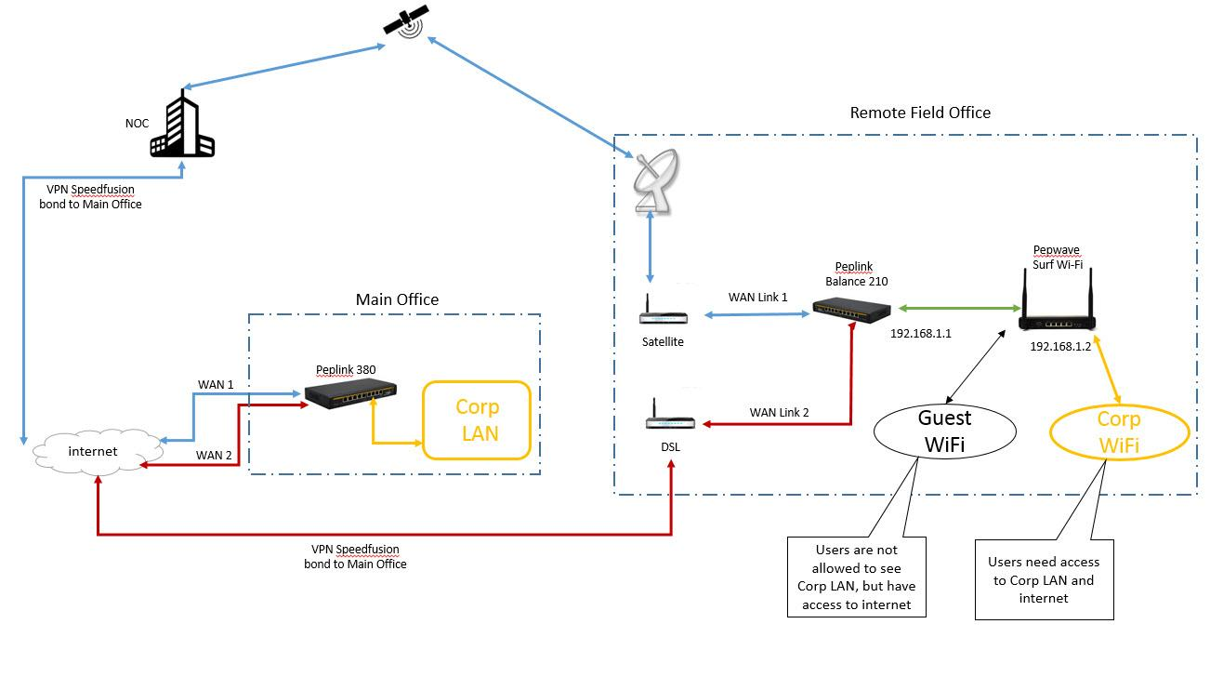
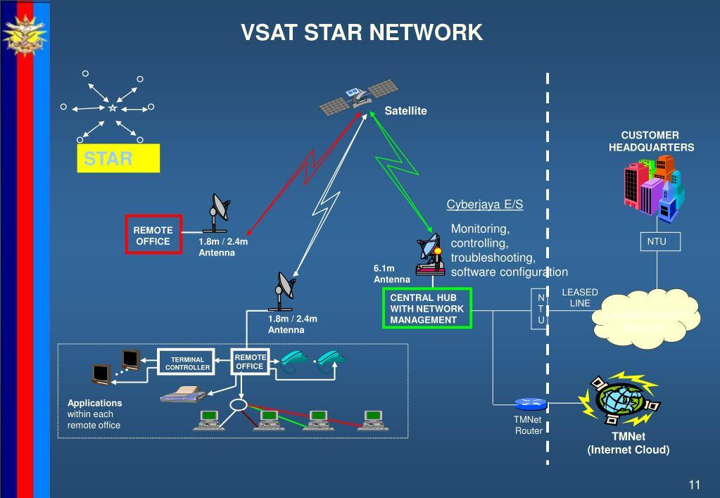

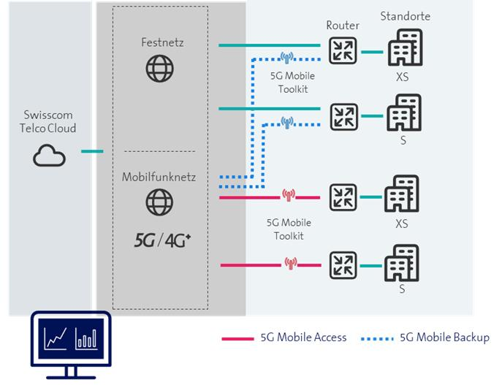
5
Proposed Network
┌──────────────────┐
│ HEADQUARTERS │
│ Corporate Network│
└────────┬─────────┘
│
Secure VPN
│
┌────────▼─────────┐
│ INTERNET │
└────────┬─────────┘
│
┌──────────────┴──────────────┐
│ │
┌─────▼─────┐ ┌─────▼─────┐
│ 4G/5G FWA │ │ Satellite │
│ Primary │ │ Backup │
└─────┬─────┘ └─────┬─────┘
│ │
└──────────────┬──────────────┘
│
┌────────▼────────┐
│ Dual-WAN Router │
│ Load balancing │
│ / Failover │
└────────┬────────┘
│
┌─────▼─────┐
│ Firewall │
└─────┬─────┘
│
┌───────▼───────┐
│ Managed Switch│
└───┬─────┬─────┘
│ │
┌───────────┘ └────────────┐
│ │
┌─────▼─────┐ ┌─────▼─────┐
│ PCs/Laptops│ │ Wi-Fi APs │
└───────────┘ └─────┬─────┘
│
Employees
Required Networking Devices
Device | Purpose
4G/5G router | Primary Internet access
Satellite/VSAT terminal | Backup connectivity
Dual-WAN router | Automatic failover
Firewall | Network protection
Managed switch | Connect wired devices
Wi-Fi 6 access point | Wireless connectivity
VPN gateway | Secure HQ communication
UPS | Protect equipment during power failure
Network monitoring system | Monitor connectivity
Security Mechanisms
1. VPN
Create an IPsec or SSL VPN tunnel between the branch and headquarters.
Branch Office
│
│ Encrypted VPN
▼
Internet
│
▼
Headquarters
│
Corporate Servers
This protects sensitive business information from interception.
2. Firewall
Deploy a next-generation firewall to:
- Block unauthorized traffic
- Control applications
- Detect suspicious traffic
- Prevent unauthorized access
- Maintain VPN policies
3. Network Segmentation
Create separate networks:
Firewall
│
Managed Switch
┌─────────┼─────────┐
│ │ │
VLAN 10 VLAN 20 VLAN 30
Staff Guest Servers
4. Authentication
Use:
- Strong passwords
- Multi-factor authentication
- WPA3 Enterprise for Wi-Fi
- Role-based access
Reliability
The most important feature is automatic failover.
Internet
│
┌─────────┴─────────┐
│ │
4G/5G Satellite
Primary Backup
│ │
└─────────┬─────────┘
▼
Dual-WAN
Router
│
Connection Monitoring
│
┌────────┴────────┐
│ │
Normal Failure
│ │
4G/5G Switch to Satellite
│ │
└────────┬────────┘
▼
Employees
Justification
Bandwidth: 4G/5G can provide better performance for cloud applications and video conferencing where coverage is good.
Reliability: A second satellite connection provides redundancy. Government satellite networks are also used for remote and inaccessible locations where satellite may be the only available primary connectivity.
Cost: Use the lower-cost cellular connection for normal traffic and reserve satellite bandwidth for backup or critical applications.
Security: Firewall + VPN + VLAN + MFA protect corporate data.
Scalability: Additional users, switches and access points can be added without redesigning the whole network.
Final Recommendation
Primary 4G/5G FWA + secondary satellite/VSAT + dual-WAN router + firewall + VPN + VLAN + Wi-Fi 6 + UPS
This gives the best balance of cost, reliability, security and scalability.

2. University Campus Wi-Fi for 3,000+ Students
Problem Analysis
The university needs wireless coverage in:
- Classrooms
- Laboratories
- Library
- Hostels
- Administrative buildings
- Common areas
More than 3,000 students may connect simultaneously.
The major challenge is not simply coverage—it is capacity and interference.
A campus WLAN should therefore use centralized management, carefully positioned APs, appropriate frequency planning and strong authentication. Campus designs commonly use a core/distribution network with wireless controllers and access points.
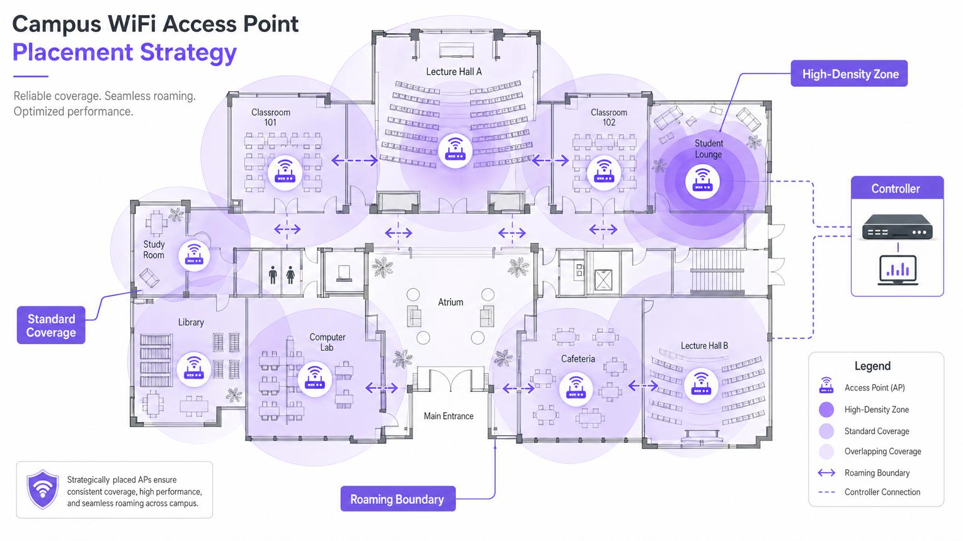
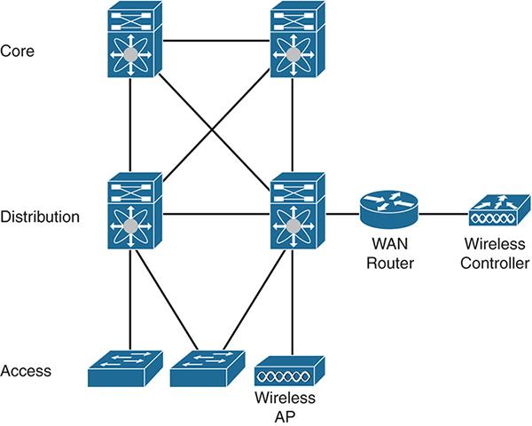
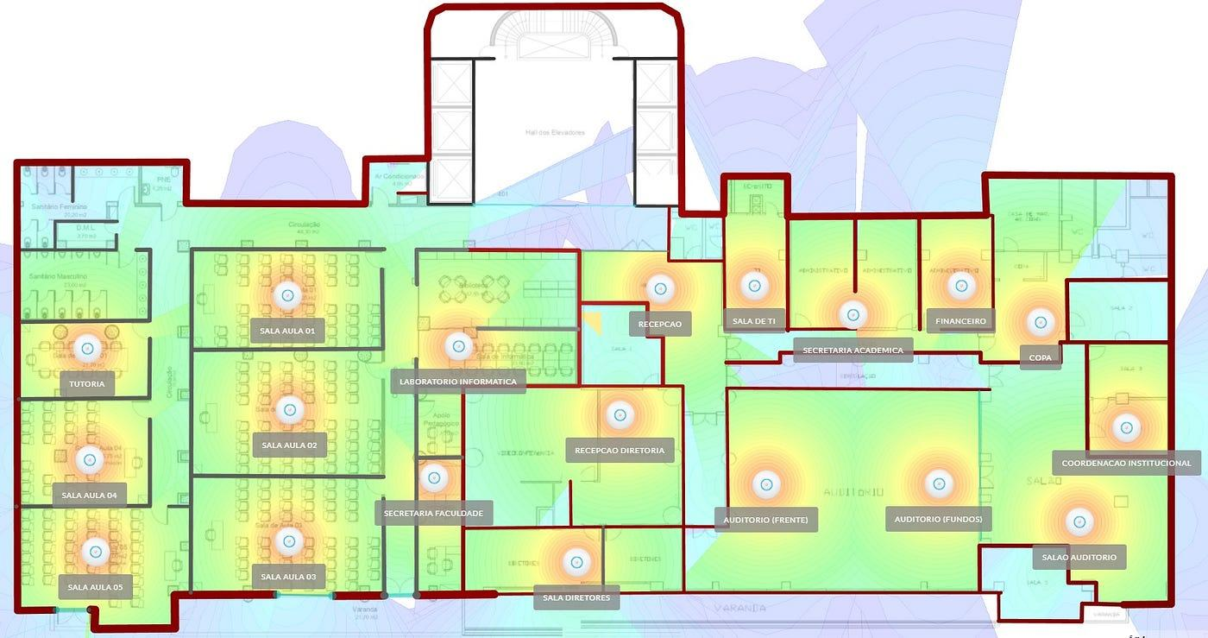
5
Proposed Architecture
INTERNET
│
┌────▼────┐
│ Firewall│
└────┬────┘
│
┌─────▼─────┐
│ Core Switch│
└─────┬─────┘
│
┌─────────▼─────────┐
│ Wireless Controller│
└─────────┬─────────┘
│
┌─────────────┼──────────────┐
│ │ │
┌───▼───┐ ┌───▼───┐ ┌───▼───┐
│Building│ │Building│ │Hostels │
│ Switch │ │ Switch │ │ Switch │
└───┬───┘ └───┬───┘ └───┬───┘
│ │ │
┌───┼───┐ ┌───┼───┐ ┌───┼───┐
AP AP AP AP AP AP
│ │ │ │ │ │
Students Students Students Students
Access Point Placement
Do not simply place APs at equal distances.
Instead, conduct a site survey.
High-density areas
Place more AP capacity around:
- Lecture halls
- Computer laboratories
- Libraries
- Hostels
- Cafeterias
- Student activity areas
A campus Wi-Fi placement strategy should use overlapping coverage carefully to support roaming while maintaining performance.
Example
UNIVERSITY CAMPUS

┌───────────────┐
│ Lecture Hall │
│ AP │
│ ● ● │
└───────┬───────┘
│
┌─────────▼─────────┐
│ Library │
│ ● ● │
└─────────┬─────────┘
│
┌───────▼────────┐
│ Computer Lab │
│ ● ● │
└───────┬────────┘
│
┌───────▼────────┐
│ Hostel │
│ ● ● ● │
└────────────────┘
Frequency Band Selection
2.4 GHz
Advantages:
- Longer range
- Better wall penetration
Disadvantages:
- More interference
- Fewer usable non-overlapping channels
- Lower capacity
5 GHz
Advantages:
- More channels
- Higher throughput
- Less interference than 2.4 GHz
- Better for high-density environments
6 GHz
If supported by the university's devices and regulations, use it for newer Wi-Fi clients because it provides additional spectrum and capacity.
Recommended approach
Wi-Fi
│
┌─────────────┼─────────────┐
│ │ │
2.4 GHz 5 GHz 6 GHz
│ │ │
IoT/old Main users New devices
devices + students
Use 5 GHz/6 GHz as the preferred bands for high-capacity student devices and retain 2.4 GHz for devices that require longer range or legacy compatibility.
Channel Planning
Avoid putting neighboring APs on the same channel unnecessarily.
Building A Building B Building C

AP1 → Ch 36 AP4 → Ch 44 AP7 → Ch 149
AP2 → Ch 40 AP5 → Ch 48 AP8 → Ch 153
AP3 → Ch 36 AP6 → Ch 44 AP9 → Ch 149
Actual channel assignments should be determined by a site survey and RF measurements.
Authentication
Use WPA3-Enterprise + 802.1X + RADIUS.
Student
│
▼
Wi-Fi AP
│
▼
802.1X Authentication
│
▼
RADIUS Server
│
├── Valid → Network Access
│
└── Invalid → Access Denied
Separate SSIDs/VLANs
Wi-Fi Network
│
┌───────────────┼────────────────┐
│ │ │
Student VLAN Faculty VLAN Guest VLAN
│ │ │
Internet + Internal Internet
academic resources only
resources
This prevents guest users from accessing university systems.
Roaming
Students should be able to move between buildings without repeatedly logging in.
Use centralized WLAN management and appropriate roaming mechanisms.
Cost Optimization
Because the university has a limited AP budget:
- Perform an RF site survey.
- Put APs where user density is highest.
- Use wired Ethernet backhaul wherever possible.
- Use centralized wireless management.
- Avoid excessive AP overlap.
- Increase capacity in high-density areas rather than deploying equal APs everywhere.
Capacity-based design
Low-density classroom
↓
1 AP

Medium-density library
↓
2–3 APs

High-density lecture hall
↓
Multiple capacity-focused APs
Final Recommendation
Centralized WLAN controller + Wi-Fi 6/6E APs + 5/6 GHz priority + limited 2.4 GHz + WPA3-Enterprise + 802.1X/RADIUS + VLAN segmentation + RF site survey
This balances coverage, performance, security and cost.

3. Financial Institution – Secure Network Architecture
Problem Analysis
A financial institution handles extremely sensitive information such as:
- Customer information
- Account information
- Transaction data
- Online banking services
- Employee credentials
Therefore, security must be designed into the network architecture rather than added later.
The main constraints are:
- Strong cybersecurity
- Regulatory compliance
- High availability
- Low latency
- Controlled operational cost
- Secure employee access
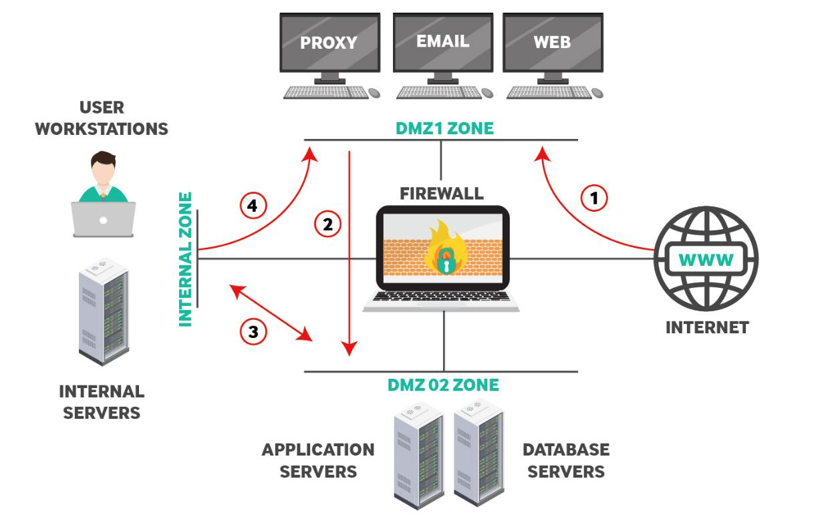
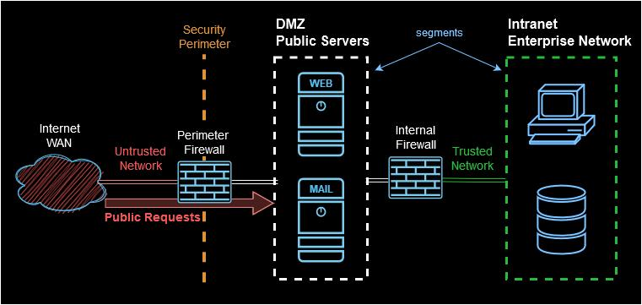
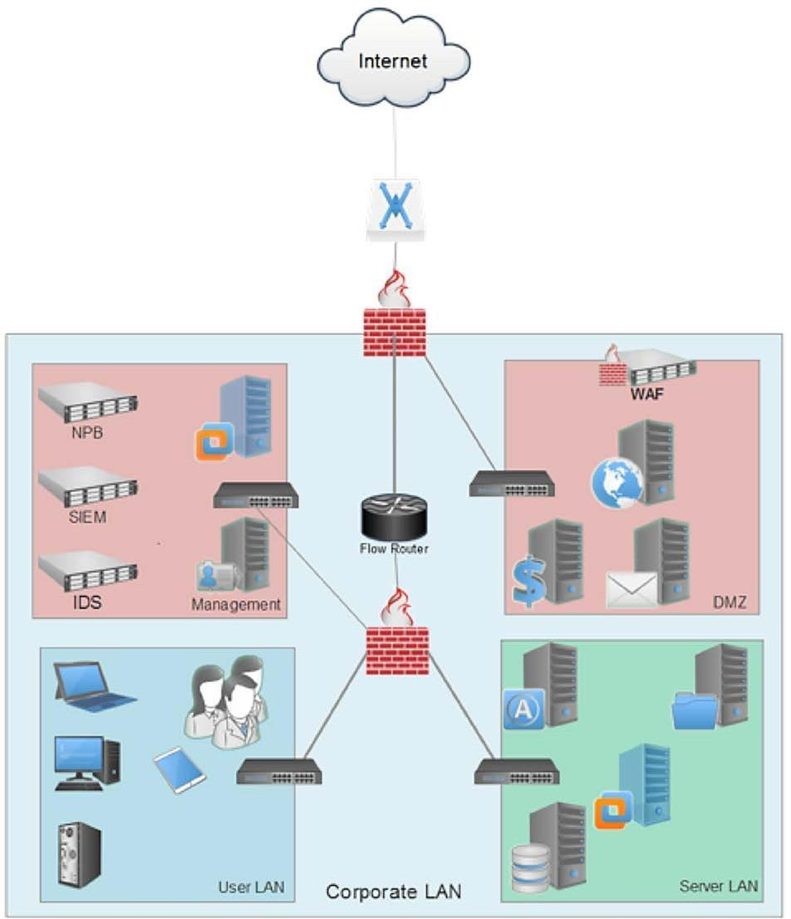
5
Recommended Architecture
Use a multi-zone segmented architecture.
INTERNET
│
┌──────▼──────┐
│ Edge Router │
└──────┬──────┘
│
┌──────▼──────┐
│ Firewall 1 │
└──────┬──────┘
│
┌──────▼──────┐
│ DMZ │
│ Web Servers │
│ VPN Gateway │
└──────┬──────┘
│
┌──────▼──────┐
│ Firewall 2 │
└──────┬──────┘
│
┌─────────▼──────────┐
│ Internal Core │
│ Network │
└─────────┬──────────┘
│
┌─────────────────┼─────────────────┐
│ │ │
Employee VLAN Server VLAN Database VLAN
│ │ │
Employees Application Customer DB
Servers

Network Segmentation
Segmentation is one of the most important controls.
Create separate VLANs/zones.
VLAN/Zone | Purpose
VLAN 10 | Employees
VLAN 20 | IT/Admin
VLAN 30 | Application servers
VLAN 40 | Database servers
VLAN 50 | Guest users
VLAN 60 | Security/Management
DMZ | Public-facing services
Example
FIREWALL
│
┌──────────────┼──────────────┐
│ │ │
DMZ Internal LAN Guest
│ │
Web Servers ┌────┼────┐
VPN Gateway │ │ │
Users Apps Database
A compromised web server therefore cannot directly access the customer database.

Firewall Deployment
Use two firewall layers.
Firewall 1 – Internet Edge
Protects the organization from:
- Internet attacks
- Port scanning
- Unauthorized connections
- Malware traffic
Firewall 2 – Internal Segmentation
Controls communication between:
- Employees
- Applications
- Databases
- Management systems
Internet
│
▼
[Firewall 1]
│
▼
DMZ
│
▼
[Firewall 2]
│
├── Employee VLAN
├── Application VLAN
├── Database VLAN
└── Management VLAN

Authentication
Use Multi-Factor Authentication (MFA).
Authentication can use:
Employee
│
▼
Username + Password
│
▼
MFA / OTP / Security Key
│
▼
Identity Server
│
├── Valid → Access
│
└── Invalid → Block
For sensitive administrative accounts, stronger authentication such as hardware security keys can be used.
Role-Based Access Control
Employees should receive only the permissions required for their jobs.
Example:
Teller
↓
Customer transaction system

Manager
↓
Transaction + reporting

IT Administrator
↓
Network management

Database Administrator
↓
Database systems
This follows the principle of least privilege.

IDS/IPS
Deploy an Intrusion Detection and Prevention System.
IDS
Detects suspicious activity and generates alerts.
IPS
Can automatically block malicious traffic.
Internet
│
▼
Firewall
│
▼
IDS/IPS
│
▼
Network
│
├── Normal Traffic → Allowed
│
└── Attack → Alert / Block
Examples of activities to detect:
- Port scanning
- Brute-force attacks
- Malware communication
- Suspicious login attempts
- Unauthorized network traffic
- Data exfiltration patterns

Secure Online Banking Architecture
Online banking services should be isolated from the internal employee network.
INTERNET
│
▼
┌───────────┐
│ Firewall │
└─────┬─────┘
│
DMZ
│
┌──────▼──────┐
│ Web Servers │
└──────┬──────┘
│
Application
Servers
│
┌──────▼──────┐
│ Database │
│ Servers │
└─────────────┘
The database should never be directly exposed to the Internet.

Complete Security Flowchart
START
│
▼
User requests access
│
▼
Identity verification
│
▼
MFA
│
┌────────┴────────┐
│ │
Failed Passed
│ │
▼ ▼
Block Determine role
│
▼
Check VLAN/Zone
│
▼
Firewall Rules
│
┌───────────┴───────────┐
│ │
Allowed Denied
│ │
▼ ▼
IDS/IPS Monitor Block
│
▼
Application Server
│
▼
Database Server
│
▼
Response

Security Monitoring
Use centralized monitoring:
Firewall ───────┐
IDS/IPS ────────┤
Servers ────────┤
Routers ────────┼──→ SIEM → Security Team
Endpoints ──────┤
Authentication ─┘
A SIEM can correlate logs and help security staff identify suspicious activity.

Performance Optimization
Security should not significantly slow down the network.
Methods
- Use high-performance firewalls.
- Use hardware-accelerated encryption where appropriate.
- Use VLANs to reduce unnecessary broadcasts.
- Use QoS for critical banking applications.
- Monitor bandwidth continuously.
- Use redundant network links for critical systems.
QoS Example
Network Traffic
│
├── Banking Transactions → HIGH priority
├── Voice/Video → HIGH priority
├── Business Applications → MEDIUM
└── Guest/Non-critical → LOW

High Availability
For a financial institution, a single device failure should not stop operations.
Internet
│
┌──────┴──────┐
│ │
Firewall A Firewall B
│ │
└──────┬──────┘
│
Core Switch
┌──────┴──────┐
│ │
Switch A Switch B
│ │
Servers Servers
Use redundant:
- Firewalls
- Core switches
- Power supplies
- Internet links
- Critical servers
- Storage systems

